Project Report Format

INTRODUCTION
  - Project Overview:
The Smart Library Request Workflow is a ServiceNow-based application that automates the process of requesting, approving, issuing, and returning library books. The system replaces manual paper-based procedures with an efficient digital workflow. Students can submit book requests, librarians can approve or reject requests, and administrators can monitor library activities through reports and dashboards.

  - Purpose:
The purpose of this project is to simplify library management by providing an automated workflow that reduces manual work, improves efficiency, maintains accurate book records, and provides secure access to students and librarians.

IDEATION PHASE
  - Problem Statement:
Many educational institutions still use manual methods to manage library book requests. These methods consume time, lead to data duplication, increase paperwork, and make it difficult to track issued and returned books. There is a need for an automated system that manages the entire library request lifecycle efficiently.

  - Empathy Map Canvas:
Students
- Want quick access to books.
- Need an easy request process.
- Expect notifications about request status.
Librarians
- Need a simple approval process.
- Want accurate inventory records.
- Need less paperwork.
Administrators
- Need reports and analytics.
- Require secure access control.
- Want centralized management.

  - Brainstorming:
Possible solutions considered:
- Manual register system
- Spreadsheet-based management
- Desktop application
- Web application
- ServiceNow workflow automation (Selected Solution)
Reason:
- Easy workflow automation
- Built-in security
- Reporting capabilities
- Scalable architecture

REQUIREMENT ANALYSIS
  - Customer Journey map:
- Student logs into the system.
- Student searches for a book.
- Student submits a request.
- Librarian reviews the request.
- Request is approved or rejected.
- Book is issued.
- Student returns the book.
- Library inventory is updated.

  - Solution Requirement:

Functional Requirements
- User login
- Book management
- Book request submission
- Approval workflow
- Book issue and return
- Status tracking
- Reports
Non-Functional Requirements
- Secure access
- High availability
- Easy usability
- Scalability
- Reliability

  - Data Flow Diagram:
Student
│
▼
Book Request
│
▼
Librarian Approval
│
┌───────┐
│Approved│
└───────┘
│
Issue Book
│
Return Book
│
Reports

  - Technology Stack:

Technology | Purpose
ServiceNow | Workflow automation
Flow Designer | Process automation
Business Rules | Backend automation
Access Control (ACL) | Security
Reports | Analytics
Tables & Forms | Data management

PROJECT DESIGN
  - Problem Solution Fit:
The proposed ServiceNow application eliminates manual book request processing by automating approvals, maintaining book inventory, and improving communication between students and librarians.

  - Proposed Solution:
The Smart Library Request Workflow enables students to request books digitally. Librarians manage approvals and book issuance while the system automatically maintains request status and book availability.

  - Solution Architecture:
Student
│
▼
Library Portal
│
▼
Book Request Table
│
▼
Flow Designer
│
▼
Librarian
│
▼
Library Book Table
│
▼
Reports

PROJECT PLANNING & SCHEDULING
  - Project Planning:
Week | Activity
Week 1 | Requirement Analysis
Week 2 | Table Creation
Week 3 | Forms & Modules
Week 4 | Flow Designer
Week 5 | Business Rules
Week 6 | Testing
Week 7 | Documentation

FUNCTIONAL AND PERFORMANCE TESTING
  - Performance Testing:
Test Case | Expected Result | Status
Login | Successful login | Pass
Create Book | Book saved | Pass
Request Book | Request created | Pass
Approve Request | Status updated | Pass
Issue Book | Inventory updated | Pass
Return Book | Inventory restored | Pass

RESULTS

  - Output Screenshots:
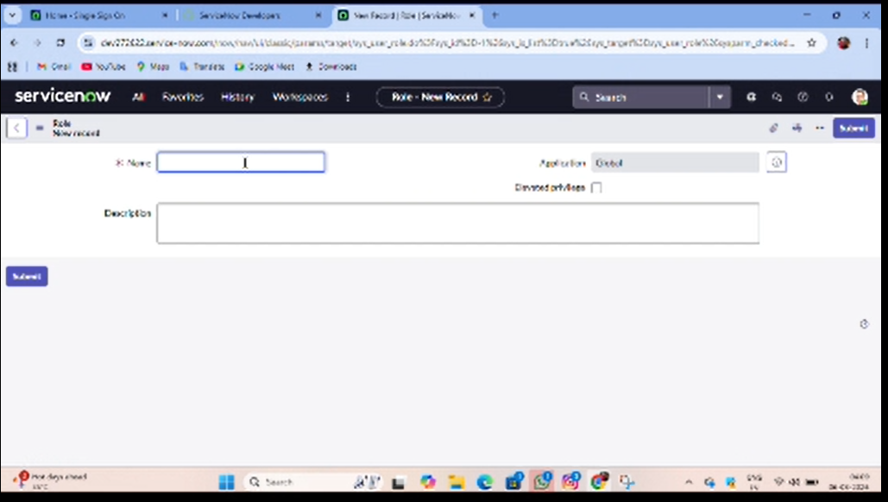

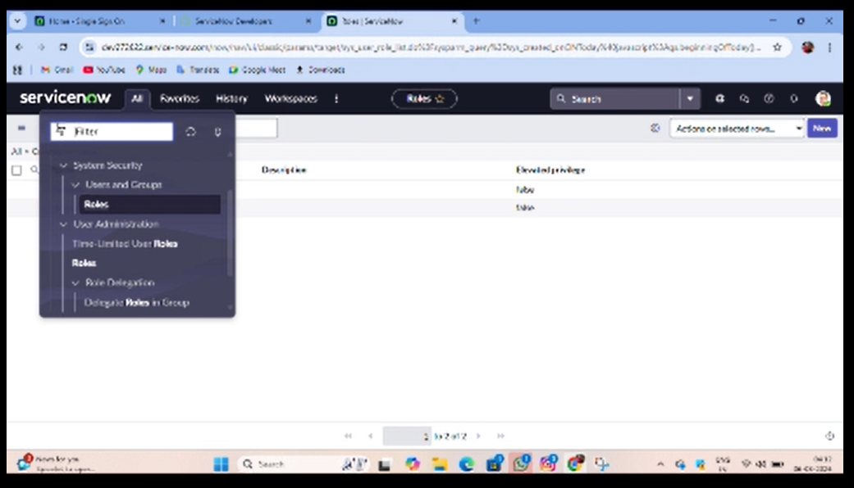

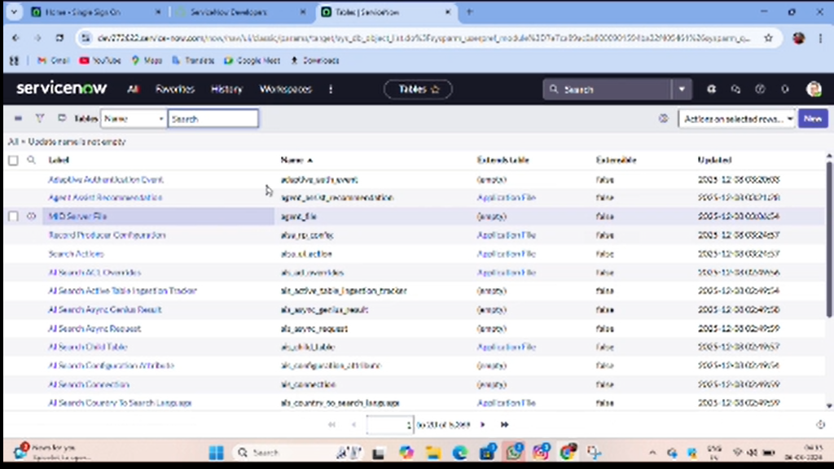

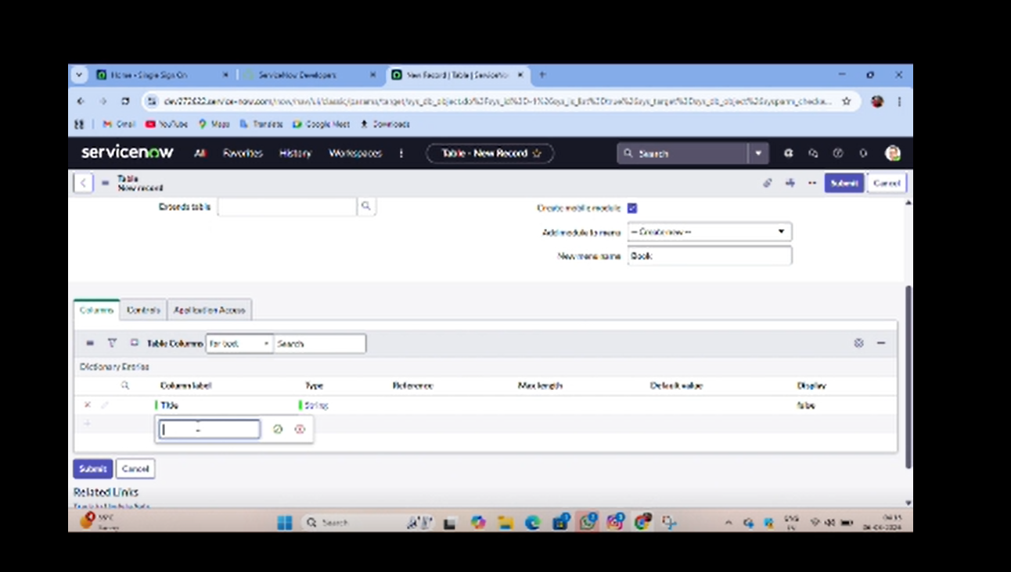

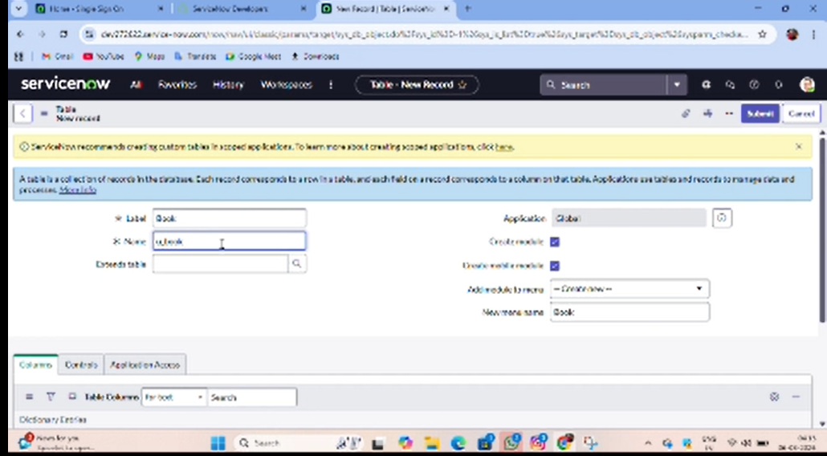

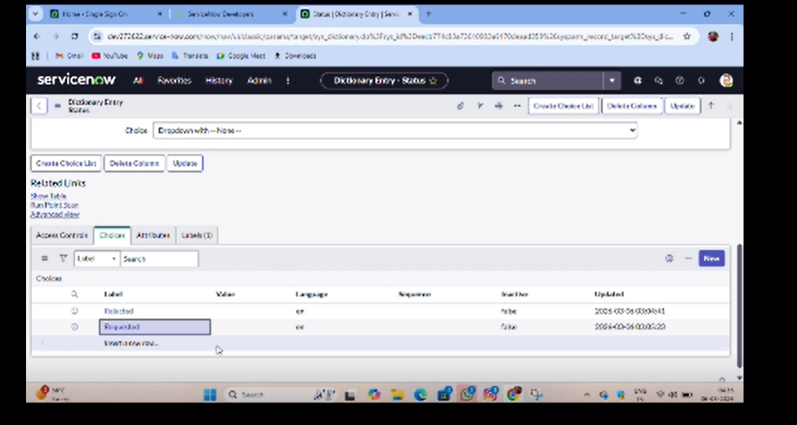

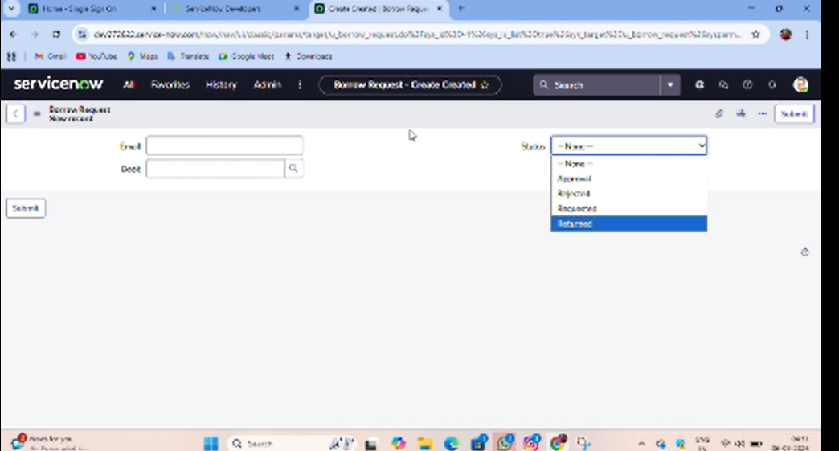

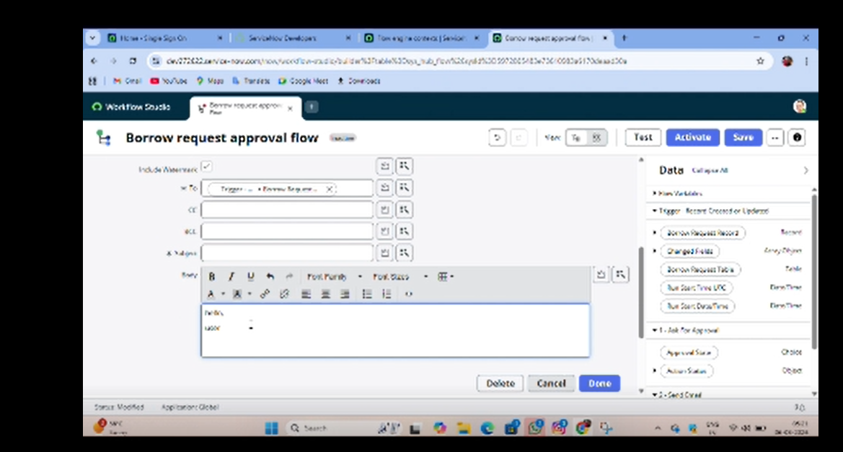

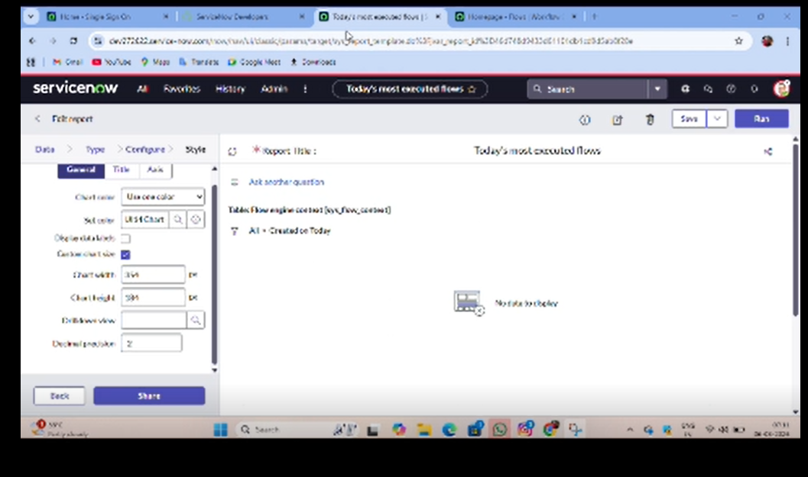

- ADVANTAGES & DISADVANTAGES:

Advantages
- Reduces manual work
- Faster approval process
- Easy inventory management
- Secure role-based access
- Better reporting
- Improved transparency
Disadvantages
- Requires internet access
- Initial setup takes time
- Users need basic training
- Depends on ServiceNow platform

- CONCLUSION:
The Smart Library Request Workflow successfully automates library operations using ServiceNow. It simplifies book request management, reduces paperwork, improves efficiency, and provides a secure environment for students and librarians. The system demonstrates how workflow automation can improve library services in educational institutions.

- FUTURE SCOPE:

- Barcode/QR code integration
- Email and SMS notifications
- Mobile application support
- AI-based book recommendations
- Fine calculation automation
- Dashboard analytics
- Integration with RFID systems

- APPENDIX
Source Code(if any)
Dataset Link:
No external dataset was used. Data was created within the ServiceNow tables (Library Book and Book Request) for testing.

GitHub & Project Demo Link:

Github link:

https://github.com/PALLIMONIKA/smart-library-request-work-flow-in-servicenow

project demolink:

https://github.com/PALLIMONIKA/smart-library-request-work-flow-in-servicenow/blob/main/demo%20link/Demo%20video%20-%20Smart%20Library%20(1).mp4

